9-Day Best of Uganda Gorilla, Chimps

On this 9-day safari tour will go tracking chimpanzee in Kibale National Park. You will also visit Semuliki and Queen Elizabeth National Parks. A gorilla trek in Bwindi Impenetrable National Park will also include a Batwa experience. The end of your tour will be to Lake Bunyonyi for a canoe tour. Come explore Africa with us
ROUTE
Uganda
Start | Entebbe (Day 1)
Day 1 | Kampala (City)
Day 2-3 | Kibale NP (Chimps)
Day 4-5 | Queen Elizabeth NP
Day 6 | Bwindi Impenetrable NP (Gorillas)
Day 7-8 | Lake Bunyonyi
End | Entebbe (Entebbe) (Day 9)

Tour Features

Mid-range tour
This mid-range tour uses lodges and resorts.

Private tour
This tour will be organized exclusively for you and won't be shared with others.

Can start any day
If availability permits, this tour can start on any day.

Cannot be customized
The accommodations and destinations of this tour cannot be changed.

Suitable for solo travelers
Solo travelers can book this private tour.
16

Minimum age of 16 years
The minimum age for this tour is 16 years.

Activities & Transportation

Activities: game drives, gorilla trekking, chimpanzee trekking & boat trip

Game drives: pop-up roof 4x4 vehicle & pop-up roof minivan

Getting around: pop-up roof 4x4 vehicle, pop-up roof minivan & air transfer

A transfer from and back to the airport is included

Accommodation & Meals
- Additional accommodation before and at the end of the tour can be arranged for an extra cost
- Day
Accommodation
Meals
- 1
Cassia LodgeMid-range lodge in Kampala (City)

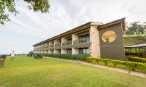

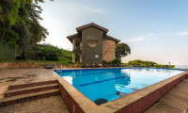

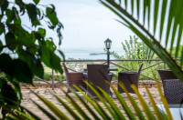

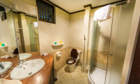+4Photos

Lunch & Dinner Included
- 2-3
Chimpanzee Forest LodgeMid-range guest house just outside Kibale NP (Chimps)

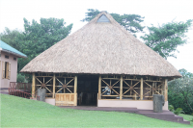

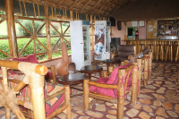

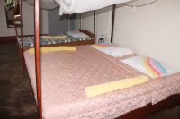

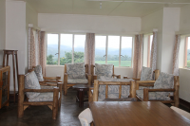

All Meals Included
- 4-5
Lake Munyanyange Caves LodgeMid-range lodge just outside Queen Elizabeth NP

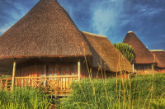

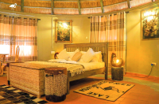

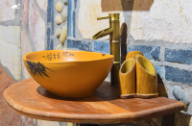

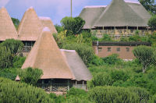+5Photos

All Meals Included
- 6
Rushaga Gorilla LodgeMid-range lodge just outside Rushaga (Bwindi Impenetrable NP)

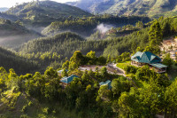

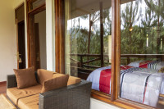

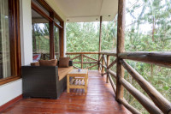

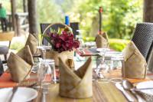+40Photos

All Meals Included
- 7-8
Lake Bunyonyi Eco ResortMid-range resort at Lake Bunyonyi

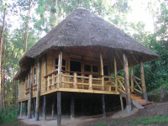

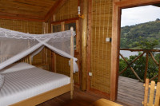

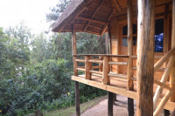

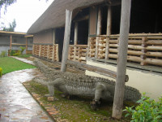

All Meals Included
- 9
End of tour
(No accommodation)
All Meals Included

Arrival (See Getting There for more details)
- You'll be collected from the airport.
- Accommodation before the tour starts can be arranged for an extra cost.
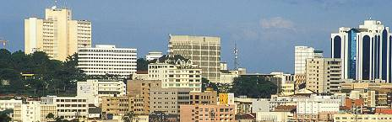

Day 1

Arrival and transfer to Hotel
Our guide will pick you up from the airport and drive you to Cassia Lodge; an inspiring destination for nature lovers and tourists alike. The grounds provide a small sanctuary for forest wildlife such as turacoe, hornbill, and other bird species. The hotel is comfortable, and provides personal service and a unique character. Whether you are searching for peace and quiet in a natural green setting or the excitement of waking up to hummingbirds, our doors are always open! Our friendly and courteous staff is always ready to welcome you with pleasure and attend to your every need. You will enjoy dinner in the evening and settle in for your overnight stay.
Main Destination:
Kampala (City)
Accommodation:
Cassia Lodge
- Mid-range lodge located in Kampala (City)







+4Photos

Meals & Drinks:
- Lunch & dinner (Breakfast not included)
- Drinking water (Other drinks not included)
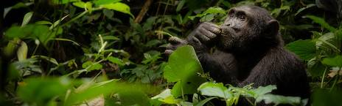

Day 2

Transfer to Kibale National Park
You will have a relaxed breakfast and at about 8 am, you can embark on a road transfer to Kibale Forest NP. The park is popular for its primates like chimpanzees, black and white colobus monkeys, red-tailed monkeys, L'Hoest's monkeys, and Uganda mangabeys (Lophocebus ugandae). You will reach Kibale in time to enjoy your lunch at the booked accommodation. Later, after some rest, you proceed for a tea plantation visit. Alternatively, you can head out to explore the Kibale Crater lakes if you love scenery, primates, and bird sightings.
Main Destination:
Kibale National Park (Chimps)
Best Time To VisitJanuary to February and June to July (Chimp trekking is easiest)
High SeasonJune to September (Peak time for Uganda)
Best WeatherJanuary to February and June to July (Least rain)

Wildlife in Kibale NP
ChimpanzeeCommon

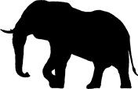
ElephantOccasional


BuffaloOccasional


LionVery Rare


LeopardVery Rare


HippoRare


GiraffeNone


White RhinoNone


Black RhinoNone


CheetahNone


ZebraNone


WildebeestNone
Accommodation:
Chimpanzee Forest Lodge
- Mid-range guest house located just outside Kibale NP (Chimps)









Meals & Drinks:
- All meals included
- Drinking water (Other drinks not included)
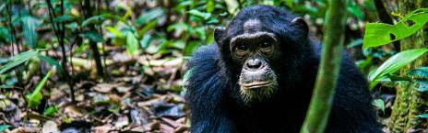

Day 3

Chimpanzee trekking and Bigodi Swamp excursion
Have breakfast then head to the rangers’ post where you will receive a briefing on the do's and don’t's during chimp trekking. Thereafter, you will proceed to trek the chimps in the Kibale Forest with an experienced ranger guide. The presence of primates here will surely amaze you. Once you locate the chimpanzees, you will have a full hour in their presence. Later, after lunch, head out for the Bigodi Wetlands excursion. Bigodi boasts an extensive array of bio-diversity including a number of primates and birds. Thereafter, you will return to the accommodation and rest.
Main Destination:
Kibale National Park (Chimps)
Accommodation:
Chimpanzee Forest Lodge
- Mid-range guest house located just outside Kibale NP (Chimps)
Meals & Drinks:
- All meals included
- Drinking water (Other drinks not included)
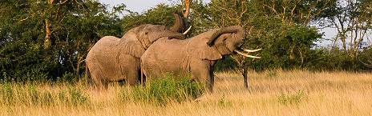

Day 4

Transfer to Queen Elizabeth NP-Evening game drive
Have a relaxed breakfast at the accommodation and then drive to Queen Elizabeth National Park. You will reach Queen Elizabeth NP early enough to relax and have lunch. In the afternoon, proceed for game viewing. During the game drive, look out for wild animals like reedbuck, bushbuck, kob, warthog, elephant, lion and buffalo to mention but a few. Alternatively, you can choose to go for the breathtaking explosion crater drive. It is a sightseeing drive with a spectacular view of the magnificent scenery in and around Queen Elizabeth NP. There is also some wildlife to see along the drive, although the most common sights are of Cape buffaloes and elephants. Return to the accommodation for relaxation, dinner and your overnight stay.
Main Destination:
Queen Elizabeth National Park
Best Time To VisitJanuary to February and June to July (Dry seasons)
High SeasonJune to September (Peak time for Uganda)
Best WeatherJune to July and January to February (Less rainfall)

Wildlife in Queen Elizabeth NP
ChimpanzeeOccasional


ElephantCommon


LionCommon


BuffaloCommon


HippoAbundant


LeopardOccasional


GiraffeNone


White RhinoNone


Black RhinoNone


CheetahNone


ZebraNone


WildebeestNone


Wild DogNone
Accommodation:
Lake Munyanyange Caves Lodge
- Mid-range lodge located just outside Queen Elizabeth NP







+5Photos

Meals & Drinks:
- All meals included
- Drinking water (Other drinks not included)
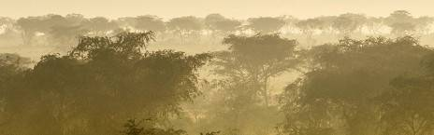

Day 5

Game Drive and Boat launch-Queen Elizabeth NP
After breakfast, you will check-out and embark on a real Ugandan African adventure traversing through the bush of Queen Elizabeth National Park. This park previously known in 1952 as Kazinga National Park was renamed to commemorate a visit by Queen Elizabeth II. On this game drive, you may see hippo, leopard, elephant, lion, and chimpanzee among other mammals and over 500 species of birds. In the afternoon, you will proceed to Mweya Peninsula for a boat ride to view the area wildlife, including the prehistoric crocodile. Once again, feast your eyes on the wonderful wildlife before you while enjoying a relaxing cruise along the Kazinga channel. Later in the day you will check-in at the Lake Munyanyange Caves lodgefor dinner and your overnight stay.
Main Destination:
Queen Elizabeth National Park
Accommodation:
Lake Munyanyange Caves Lodge
- Mid-range lodge located just outside Queen Elizabeth NP
Meals & Drinks:
- All meals included
- Drinking water (Other drinks not included)
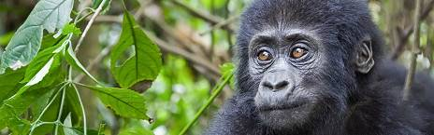

Day 6

Transfer to Bwindi Impenetrable national Park
Today you will set off quite early with packed breakfast and head out for an early morning game drive in the Kasenyi plains of Queen Elizabeth National Park to catch sight of the early risers. Expect to see a number of elephants, buffaloes, lions, waterbucks, Uganda kobs, leopards, hyenas. Thereafter, we will proceed to Bwindi Impenetrable National Park.
Main Destination:
Bwindi Impenetrable National Park (Gorillas)
Best Time To VisitJune to August and December to February (Gorilla trekking is easiest)
High SeasonJune to September (Gorilla permits are scarce)
Best WeatherJune to July and December to February (Less rainfall)

Wildlife in Bwindi Impenetrable NP

GorillaCommon

ChimpanzeeRare


ElephantRare


White RhinoNone


Black RhinoNone


LionNone
Show more
Accommodation:
Rushaga Gorilla Lodge
- Mid-range lodge located just outside Rushaga (Bwindi Impenetrable NP)







+40Photos

Meals & Drinks:
- All meals included
- Drinking water (Other drinks not included)
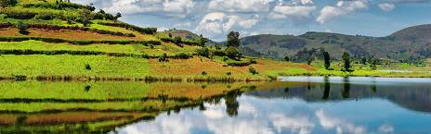

Day 7

Gorilla Trekking and transfer to Lake Bunyonyi
We begin today’s activity with the much-awaited Gorilla Trekking in Bwindi Impenetrable National Park, home to half of the Gorilla living in this world.
After Gorilla tracking, the Batwa experience in Karengerere follows where your guide will take you at the top of the hills to take in the great view of Lake Bunyonyi.
Main Destination:
Lake Bunyonyi
Accommodation:
Lake Bunyonyi Eco Resort
- Mid-range resort located at Lake Bunyonyi









Meals & Drinks:
- All meals included
- Drinking water (Other drinks not included)
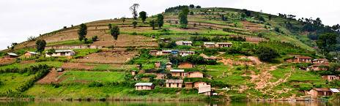

Day 8

Lake Bunyonyi activities
After breakfast, you will embark on a canoe ride to enjoy the serene ambiance and breathtaking views of Lake Bunyonyi. You can also go on a village walk and immerse in the African community and culture. Apart from its beauty, Lake Bunyonyi is also known as a place for little birds. In fact “Bunyonyi” translates to “place of many little birds” and encircles 29 islands of various shapes and sizes. You can also visit the underprivileged children of Loving Hearts Helping Hands primary school. They will welcome you with the utmost hospitality and provide you with a short concert or traditional dance. After your visit, you will return to the resort for dinner and your overnight stay.
Main Destination:
Lake Bunyonyi
Accommodation:
Lake Bunyonyi Eco Resort
- Mid-range resort located at Lake Bunyonyi
Meals & Drinks:
- All meals included
- Drinking water (Other drinks not included)
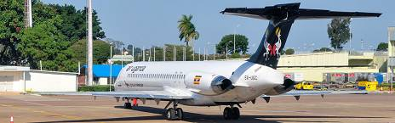

Day 9

Transfer to Entebbe-End of Trip
After breakfast, you will check-out and drive back to Kampala. You will have lunch along the drive, stopping at the Equator for the chance to take some breathtaking pictures, shopping and may be try a Ugandan Rolex. Upon arrival in Kampala, you will be dropped off at the Entebbe International Airport. This is where your safari will end.
Main Destination:
Entebbe International Airport (Entebbe)
Accommodation:
No accommodation (End of tour)
Meals & Drinks:
- All meals included
- Drinking water (Other drinks not included)

End of tour
- Additional accommodation can be arranged for an extra cost.
- You'll be dropped off at the airport.

Rates

Important to Know
- Rates are per person and exclude the international flight from/to your home country.
- This tour accepts children who are 16 years and older.
- Rates include a fixed budget for flights during this tour. Flights may cost more, depending on travel dates. If so, your quote will reflect this.

Rates Per Person
Start dates | Solo1 room | 2+ people Sharing rooms
Jan 1, 2026 - Dec 31, 2026 | $3,630 | $3,135
Jan 1, 2027 - Dec 31, 2027 | $3,630 | $3,135

InclusionsGetting ThereOffered By

Included
- Park fees(For non-residents)
- Gorilla permits(One per person, non-resident)
- Chimp permits(One per person, non-resident)
- All activities(Unless labeled as optional)
- All accommodation(Unless listed as upgrade)
- A professional driver/guide
- All transportation(Unless labeled as optional)
- All flights during the tour
- All Taxes/VAT
- Roundtrip airport transfer
- Meals(As specified in the day-by-day section)
- Drinking water(On all days)

Excluded
- International flights(From/to home)
- Additional accommodation before and at the end of the tour
- Tips(Tipping guideline US$10.00 pp per day)
- Personal items(Souvenirs, travel insurance, visa fees, etc.)
- Government imposed increase of taxes and/or park fees

